Aim: To understand the process of convolution over the image and apply over the classification problem.
IDE: Google Colab
Theory:
Convolutional Neural Networks (CNN) are complex feed forward neural networks. CNNs are used for image classification and recognition because of its high accuracy There are three types of layers in a convolutional neural network: i. Convolutional layer ii. Pooling layer iii. Fully connected layer Each of these layers has different parameters that can be optimized and performs a different task on the input data.

What is Pooling Layer?
Pooling layer is responsible for reducing the spatial size of the Convolved Feature. This is to decrease the computational power required to process the data through dimensionality reduction. There are two types of Pooling i. Average Pooling. ii. Max Pooling Max Pooling returns the maximum value from the portion of the image covered by the Kernel. On the other hand, Average Pooling returns the average of all the values from the portion of the image covered by the Kernel. Max Pooling also performs as a Noise Suppressant. It discards the noisy activations altogether and also performs de-noising along with dimensionality reduction. On the other hand, Average Pooling simply performs dimensionality reduction as a noise suppressing mechanism. Hence, we can say that Max Pooling performs a lot better than Average Pooling.

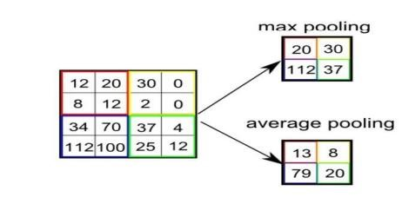

What is Convolutional Layer?
Convolutional layers are the major building blocks used in convolutional neural networks. A convolution is the simple application of a filter to an input that results in an activation. Repeated application of the same filter to an input results in a map of activations called a feature map, indicating the locations and strength of a detected feature in an input, such as an image. A convolutional layer contains a set of filters whose parameters need to be learned. The height and weight of the filters are smaller than those of the input volume. Each filter is convolved with the input volume to compute an activation map made of neurons.

What is Fully Connected Layer?
A fully connected layer that takes the output of convolution/pooling and predicts the best label to describe the image We have three layers in the full connection step i. Input layer ii. Fully-connected layer iii. Output layer

Input Layer: It takes the output of the previous layers, “flattens” them and turns them into a single vector that can be an input for the next stage.

Fully Connected Layer: It takes the inputs from the feature analysis and applies weights to predict the correct label.

Output Layer: It gives the final probabilities for each label.

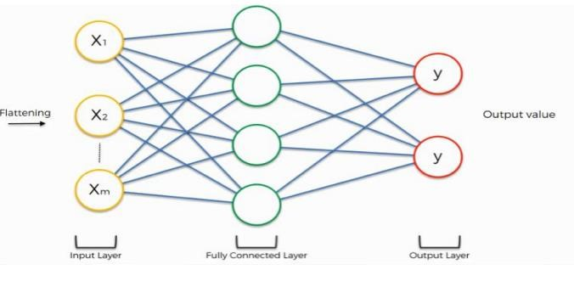

ReLU Layer: ReLU is an activation function. Rectified Linear Unit (ReLU) transform function only activates a node if the input is above a certain quantity, while the input is below zero, the output is zero, but when the input rises above a certain threshold, it has a linear relationship with the dependent variable. The main aim is to remove all the negative values from the convolution. All the positive values remain the same but all the negative values get changed to zero.

Methodology:
- Load the basic libraries and packages
- Load the dataset
- Analyse the dataset
- Normalize the data
- Pre-process the data
- Visualize the Data
- Write the CNN model function
- Write the Cost Function
- Write the Gradient Descent optimization algorithm
- Apply the training over the dataset to minimize the loss
- Observe the cost function vs iterations learning curve

Program (Code):
To be attached with
# Step 1: Import libraries
import tensorflow as tf
from tensorflow.keras import datasets, layers, models
import matplotlib.pyplot as plt

# Step 2: Load dataset (MNIST)
(X_train, y_train), (X_test, y_test) = datasets.mnist.load_data()

# Step 3: Normalize data
X_train = X_train / 255.0
X_test = X_test / 255.0

# Reshape for CNN
X_train = X_train.reshape(-1,28,28,1)
X_test = X_test.reshape(-1,28,28,1)

# Step 4: Build CNN Model
model = models.Sequential([
layers.Conv2D(32, (3,3), activation='relu', input_shape=(28,28,1)),
layers.MaxPooling2D((2,2)),

layers.Conv2D(64, (3,3), activation='relu'),
layers.MaxPooling2D((2,2)),

layers.Flatten(),
layers.Dense(64, activation='relu'),
layers.Dense(10, activation='softmax')
])

# Step 5: Compile model
model.compile(optimizer='adam',
loss='sparse_categorical_crossentropy',
metrics=['accuracy'])

# Step 6: Train model
history = model.fit(X_train, y_train, epochs=5, validation_data=(X_test, y_test))

# Step 7: Evaluate
test_loss, test_acc = model.evaluate(X_test, y_test)
print("Test Accuracy:", test_acc)

# Step 8: Plot accuracy & loss
plt.plot(history.history['accuracy'], label='train acc')
plt.plot(history.history['val_accuracy'], label='val acc')
plt.legend()
plt.title("Accuracy vs Epochs")
plt.show()

plt.plot(history.history['loss'], label='train loss')
plt.plot(history.history['val_loss'], label='val loss')
plt.legend()
plt.title("Loss vs Epochs")
plt.show()

Results:
To be attached with
- Training dataset
- Model summary
- Training and validation accuracy w.r.t epochs before regularization
- Training and validation loss w.r.t epochs before regularization
- Training and validation accuracy w.r.t epochs after regularization
- Training and validation loss w.r.t epochs after regularization
- Original v/s predicted labels for correct predicted observations
- Original v/s predicted labels for incorrect predicted observations

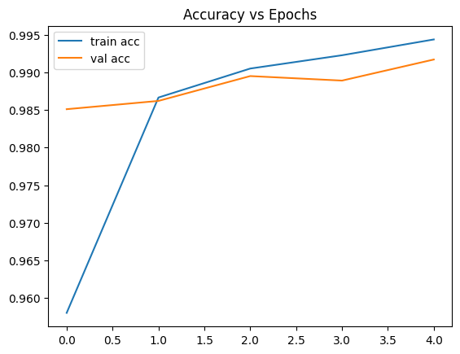
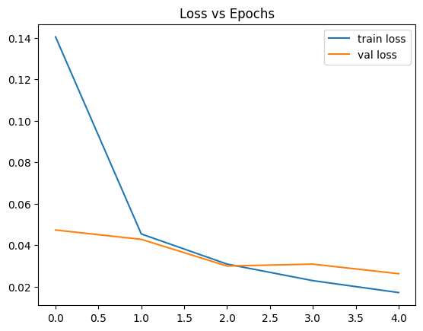
Pre Lab Exercise:
a. What is Convolution process? Explain giving example.
Convolution is a mathematical operation where a filter (kernel) is applied over an image to extract features like edges, textures, etc.________________________________________
Example:_-______________________________________________________________
A 3×3 filter moves over an image matrix and performs element-wise multiplication and___ summation to produce a feature map.__________________________________________
- Input Image → Matrix
- Kernel → Small matrix
- Output → Feature map

b. What are different layers in CNN model?
1. Convolutional Layer – extracts features_____________________________________
2. Pooling Layer – reduces dimensions_________________________________________
3. Fully Connected Layer – classification________________________________________
4. Activation Layer (ReLU) – introduces non-linearity______________________________
________________________________________________________________________
- What is the requirement of the pooling layer in the CNN model?
- Reduces size of feature maps______________________________________________
- Decreases computation__________________________________________________
- Helps prevent overfitting_________________________________________________
- Extracts dominant features_______________________________________________
________________________________________________________________________
- What is the requirement of the use of ReLU activation function after convolution step?
- Removes negative values (sets to 0)________________________________________
- Introduces non-linearity__________________________________________________
- Speeds up training______________________________________________________
- Helps model learn complex patterns________________________________________
________________________________________________________________________
Observation and Result Analysis:
- Nature of the dataset
- Image dataset (handwritten digits)_________________________________________
- Grayscale images (28×28)________________________________________________
- Multi-class classification__________________________________________________
________________________________________________________________________

- Training Process without regularization
- High training accuracy___________________________________________________
- Risk of overfitting_______________________________________________________
- Validation accuracy slightly lower__________________________________________
________________________________________________________________________

- After regularization in the training Process
- Reduced overfitting_____________________________________________________
- Improved generalization_________________________________________________
- Validation accuracy improves_____________________________________________
________________________________________________________________________

- Observation over the Learning Curves
- Accuracy increases with epochs___________________________________________
- Loss decreases gradually_________________________________________________
- Gap between train & validation shows overfitting_____________________________
________________________________________________________________________

Post Lab Exercise:
- Why CNN is preferred over ANN for images
- CNN captures spatial features____________________________________________
- Requires fewer parameters_______________________________________________
- Better accuracy for images________________________________________________
________________________________________________________________________
- Can CNN be applied over Text data? If yes, then how. If no, then why?
Yes,
- Convert text → word embeddings__________________________________________
- Apply 1D convolution____________________________________________________
- Used in sentiment analysis________________________________________________
________________________________________________________________________ c. What is the role of dropout layer?
- Randomly disables neurons during training_____________________________
- Prevents overfitting________________________________________________
- Improves generalization_____________________________________________
________________________________________________________________________

d. What will happen if maxpooling is replaced with minpooling?
1. Important features may be lost____________________________________________
2. Noise may increase______________________________________________________
3. Model performance decreases_____________________________________________
________________________________________________________________________

